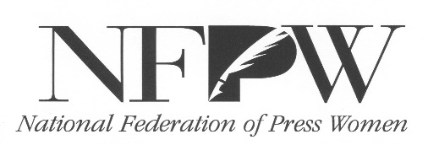
NFPW Communications Contest Sweepstakes Winners
1969 -- Bobbie McCallum, Washington
1970 -- Sel Yackley, Illinois
1971 -- Betty Penson, Idaho
1972 -- Dorothee Polson, Arizona
1973 -- Marcia Donnan, South Dakota
1974 -- Hazel Geissler,Florida
1975 -- Barbara Page, New Mexico
1976 -- Verneeta Gowens, Illinois
1977 -- Joan LaLiberte, Idaho
1978 -- Marilyn Newton, Nevada
1979 -- Lyn Alweis, Colorado
1980 -- Karen Worley, Missouri
1981 -- Andree Brooks, Connecticut
1982 -- Jane Flink, Missouri
1983 -- Marjie Lundstrom, Colorado
1984 -- Cathy Mauk, North Dakota
1985 -- Cathy Mauk, North Dakota
1986 -- Carol Renner, Minnesota
1987 -- Carol Ankney Michigan and Sharon Nesbit, Oregon
1988 -- Carol Ankney, Michigan
1989 -- Brenda Blagg, Arkansas
1990 -- Sharon Nesbit, Oregon
1991 -- Valerie Wiener, Nevada
1992 -- Carol Osman Brown, Arizona
1993 -- Denis Law, Washington
1994 -- Louise Wood, Texas
1995 -- Dan Abernathy, Wyoming
1996 -- Mary Jane Skala, Ohio
1997 -- Elizabeth Spence, Louisiana
1998 -- Jane Lee, Kansas
1999 -- Suzanne Martinson, Pennsylvania
2000 -- Karen Feld, Washington, D.C.
2001 -- Tracy Bryant, Delaware
2002 -- Sara Virzi, South Carolina
2003 -- Jimmy Tomlin, North Carolina
2004 -- Barbara Micek, Nebraska
2005 -- Mindie Paget, Kansas
2006 – No award
2007 -- Julie Grimm, New Mexico
2008 -- Lori Potter, Nebraska
2009 -- Martin Fredricks, North Dakota
2010 -- Debbie Miller, Arkansas
2011 -- Tammy Keith, Arkansas
2012 -- Lori Potter, Nebraska
2013 -- Karen Stensrud, North Dakota
2014 -- Lori Potter, Nebraska
2015 -- Lini Kadaba, Pennsylvania
2016 – Pamela Knudson, North Dakota
2017 – Tammy Keith, Arkansas
2018 – Lori Potter, Nebraska
2019 – Karen Stensrud, North Dakota

