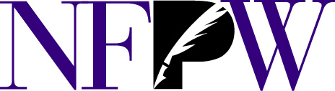
The National Federation of Press Women, Inc.
140B Purcellville Gateway Dr., Suite 120, Purcellville, VA 20132 · (571) 295-5900 info@nfpw.org · www.nfpw.org

FOR IMMEDIATE RELEASE
June 25, 2022
Contact:
Teri Ehresman, NFPW National Contest Director (islandpark723@gmail.com; 208-521-5171)
More information: www.nfpw.org
National Federation of Press Women announce national award winners
Communicators from throughout the United States were honored June 25, 2022, during the National Federation of Press Women communications contest ceremony in Fargo, North Dakota.
Nearly 2,000 entries were submitted in this year’s contest including entries from Alabama, Alaska, Arizona, Arkansas, California, Colorado, Connecticut, Delaware, Florida, Idaho, Illinois, Indiana, Iowa. Kansas, Kentucky, Louisiana, Maryland, Massachusetts, Michigan, Minnesota, Missouri, Nebraska, New Hampshire, New Jersey, Nevada, New Mexico, New York, North Carolina, North Dakota, Ohio, Oregon, Pennsylvania, South Carolina, South Dakota, Tennessee, Texas, Virginia, Washington and Washington, D.C.
The following award recipient was honored during the 2022 NFPW Communications Contest Awards celebration.

Name: ___________________________________________________________________
Title: _____________________________________________________________________
Hometown: ______________________________________________________________
Category: __________________________________________________________________

NFPW is a nationwide organization of women and men pursuing careers across the communications spectrum, including print and electronic journalism, freelancing, new media, books, public relations, marketing, graphic design, photography, advertising, radio and television.
A distinguished group of professional journalists, communications specialists and educators judged nearly 2,000 entries in a wide variety of categories. Only first-place winning entries at the state level are eligible to enter the national contest. All entries were published or broadcast between Jan. 1, 2021, and Dec. 31, 2021.

